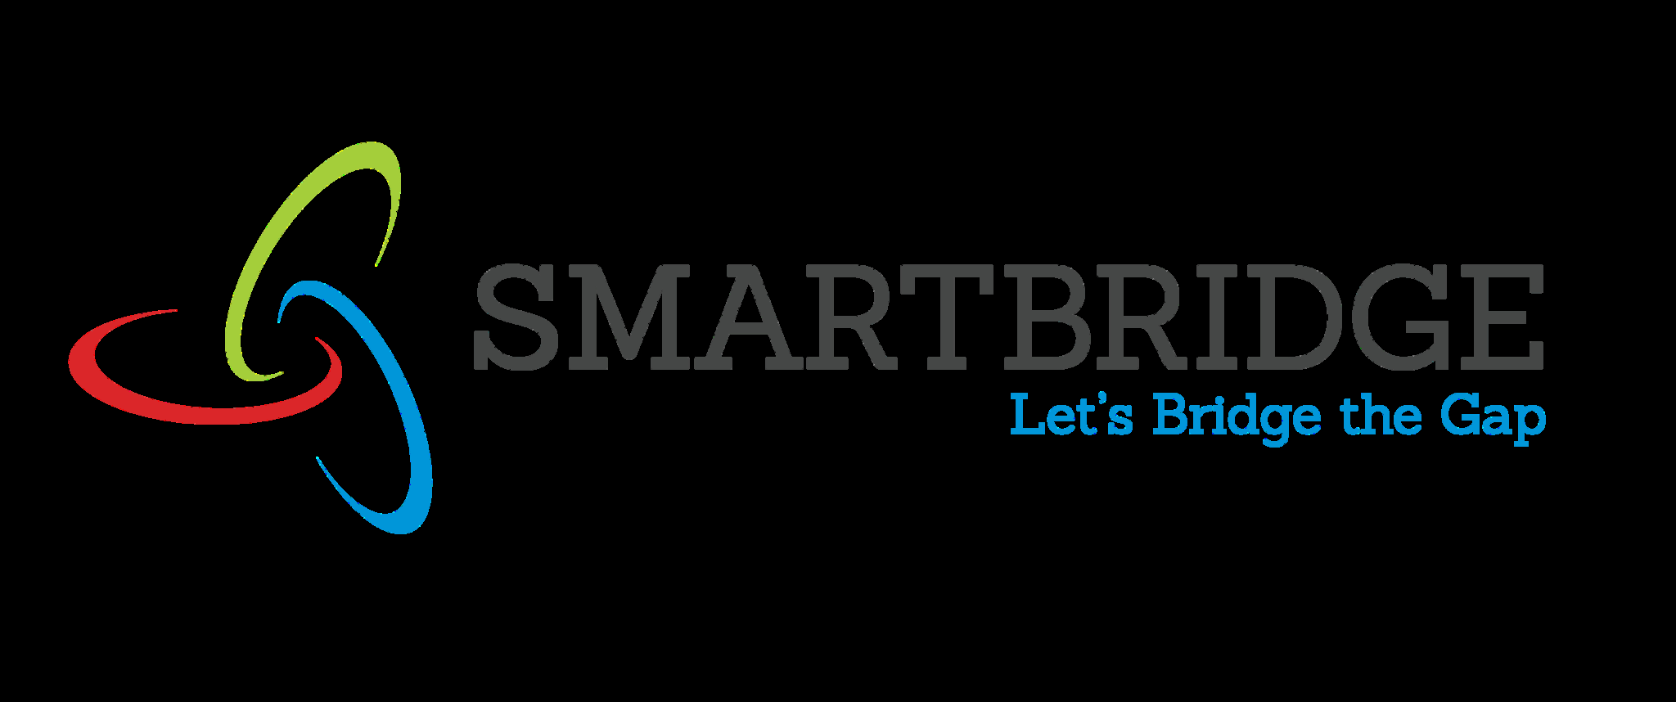 | 
Empathy Map
Date | 02 July 2026
Team ID
Project Name | Darshan Ease – Temple Darshan Ticket Booking System
Maximum Marks | 4 Marks

Empathy Map
Create an empathy map to understand your customer/user from four perspectives - what they Say, Think, Do, and Feel - in relation to the problem your project addresses. This helps the team build a customer-centric solution.
SAYS  - “I don't want to stand in a long queue just to get a darshan ticket.”  - “I wish I could check slot availability before travelling.”  - “I need my ticket handy on my phone, not a printed slip.” | THINKS  - Will I get a slot on the day I want to visit?  - Is this booking website secure with my details?  - It would help to see my past bookings in one place.
Devotee
(End User booking darshan)
DOES  - Searches online for temple timings and availability.  - Registers and logs in to book a darshan slot.  - Shares the e-ticket with family members travelling together. | FEELS  - Anxious about not finding a confirmed slot in time.  - Relieved once the booking is confirmed instantly.  - Confident returning to the app for future visits.

